Install WordPress Website Over EC2 (ubuntu) Instance

Step 1: create an instance with ubuntu as AMI Here my instance name is Wordpress

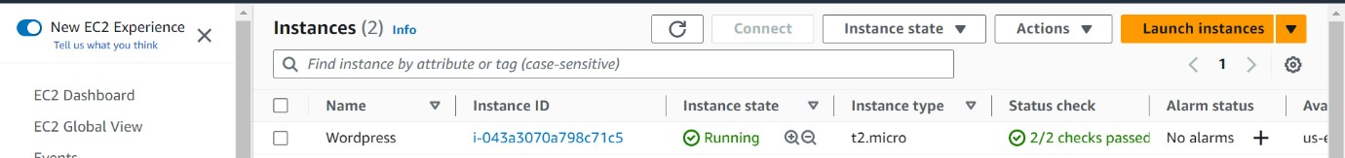

Step 2:connect instance and deploy LAMP stack

-click on connect

-command:1.sudo apt-get update -y

1. sudo apt-get upgrade -y
2. sudo apt-get install apache2 -y
3. check status: sudo systemctl status apache2
4. If status in inactive than : sudo systemctl start apache2

After that: sudo systemctl enable apache2 :(this will keep the service running Even after reboot the machine)

-Deploy Database Server: run this command

1. sudo apt install mariadb-server mariadb-client -y



1. sudo systemctl start mariadb

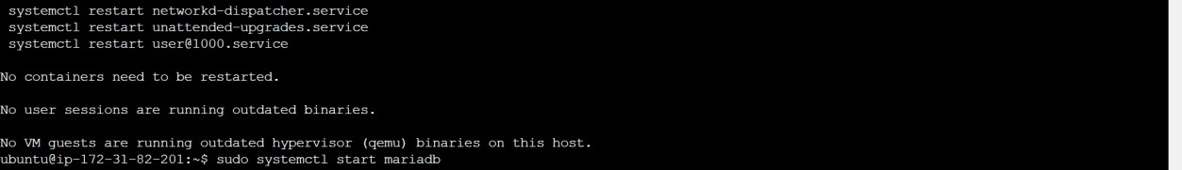

1. sudo systemctl status mariadb

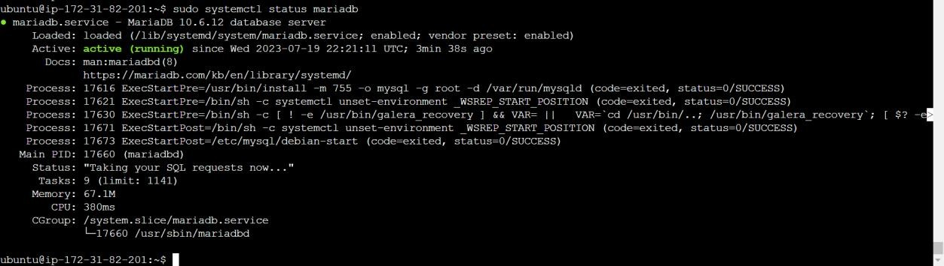

1. set up ROOT password :

-command: sudo mysql_secure_installation

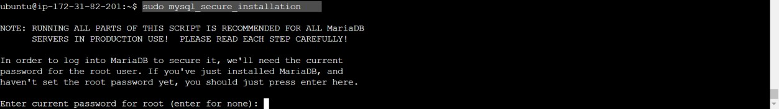

-press enter

Switch to unix_socket authentication [Y/n] y Change the root password? [Y/n] y

New password: (enter any password)

Re-enter new password:(re-enter that password) Remove anonymous users? [Y/n] y

Disallow root login remotely? [Y/n] y

Remove test database and access to it? [Y/n] y

-Than restart the MariaDB: sudo systemctl restart mariadb

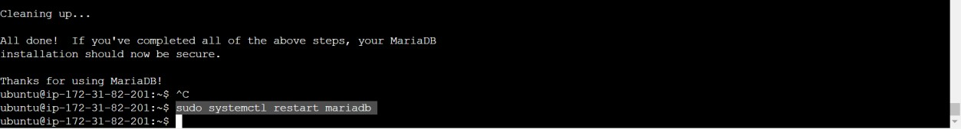

-Install PHP:

Command: sudo apt install php php-mysql php-gd php-cli php-common -y



-Reload the page

-Install Wordpress :

Command: - sudo apt install wget unzip -y



-sudo wget <https://wordpress.org/latest.zip>



-ls

-sudo unzip lastest.zip



-ls

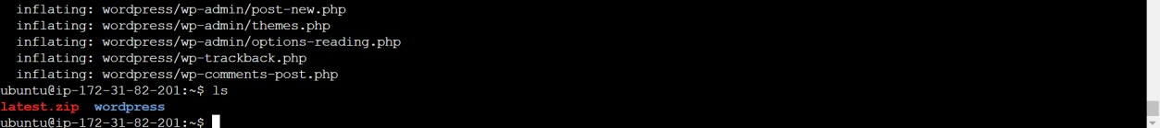

Here we got out wordpress directory

We copy all content in wordpress to our document root of apache server Command: -sudo cp -r wordpress/* /var/www/html/

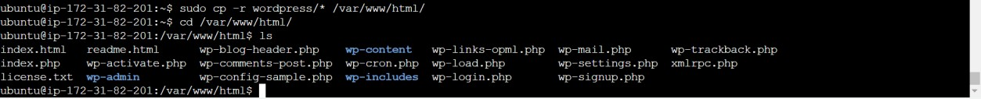

your files are copied .

Than you to change the ownership of the file from root to www-data: Command: for check ownership: - ls -l

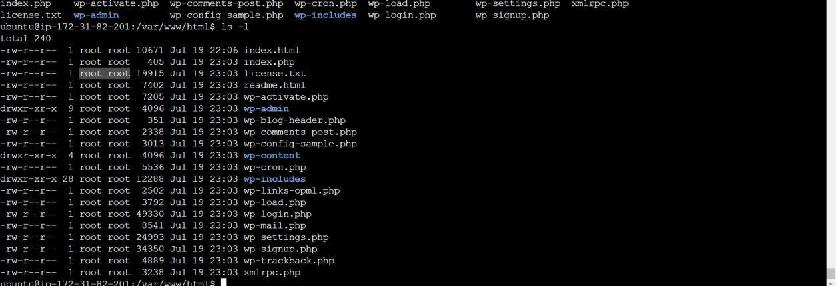

This are set as root

For changing type: -sudo chown www-data:www-data -R /var/www/html/

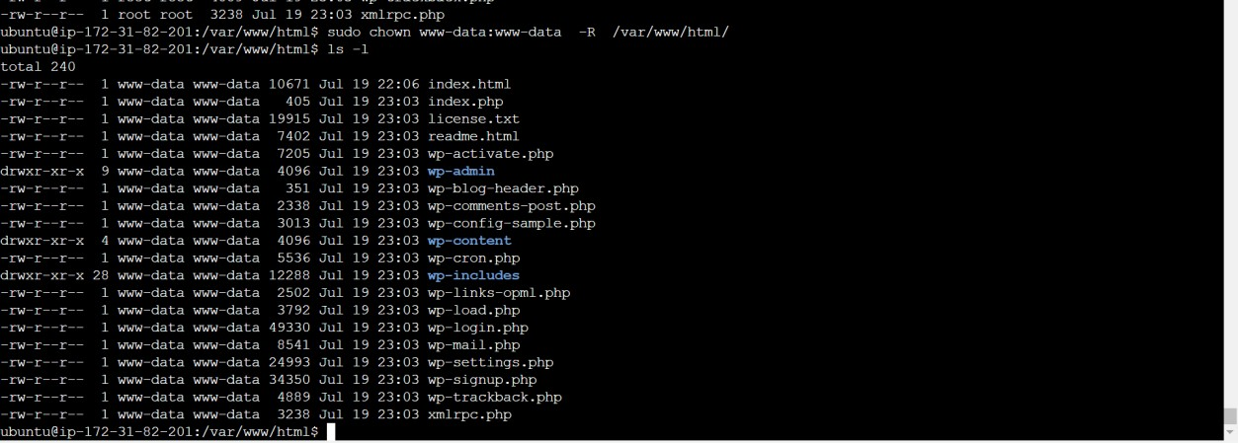

Thus ownership is changes.

Delete index.html file because they show at the top So for delete:

-sudo rm -rf index.html

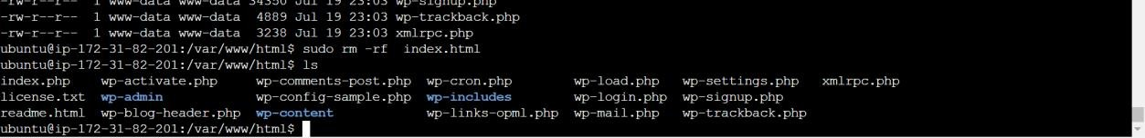

Our index.html successfully deleted Step 4:

-copy public ip paste on chrome tab

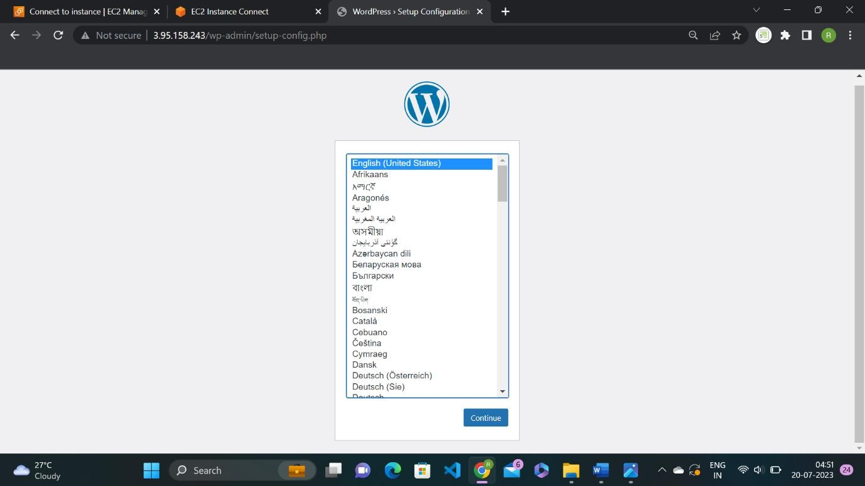

Click on continue <let’s go

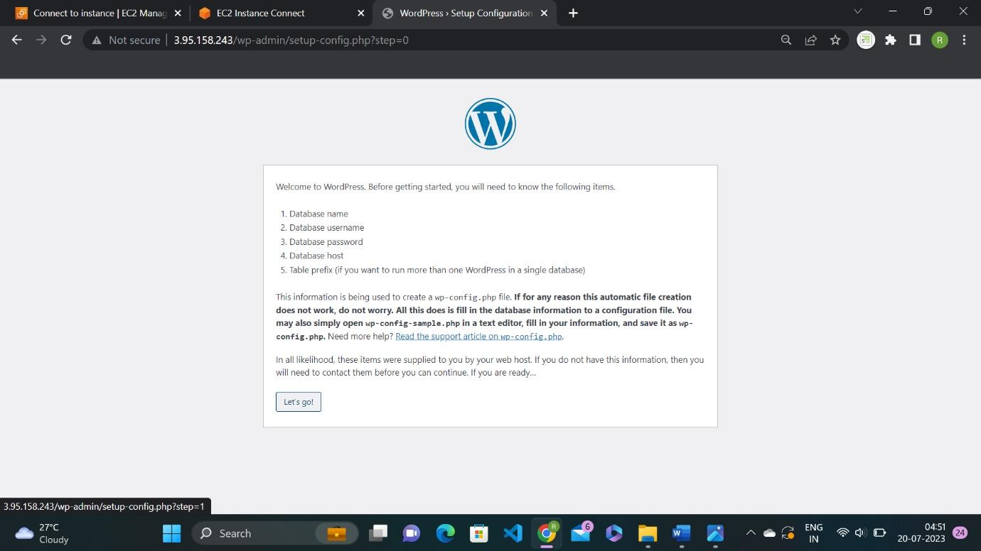

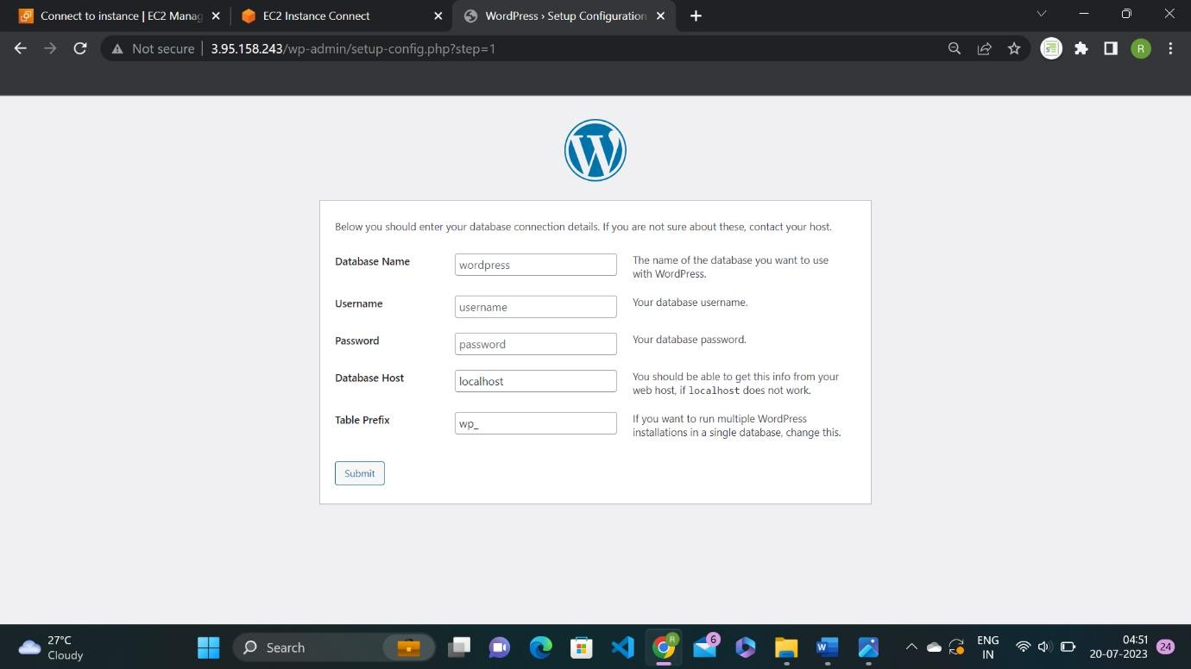

Step 5: create database name ,username ,password Go to -cd

Command: sudo mysql -u root -p Type your password

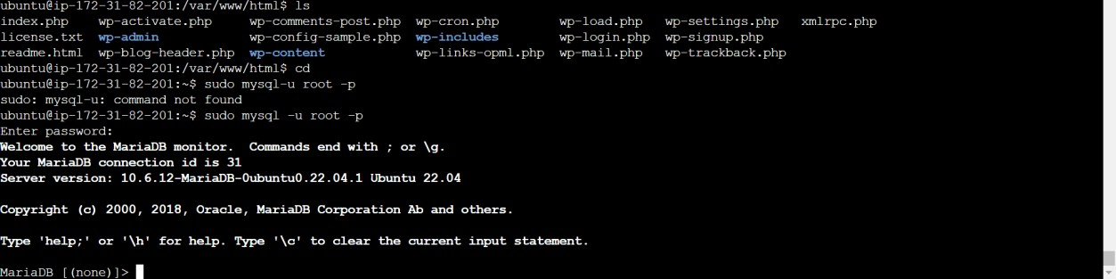

You are in a mariadb database

-for creating database : create database (name of database);

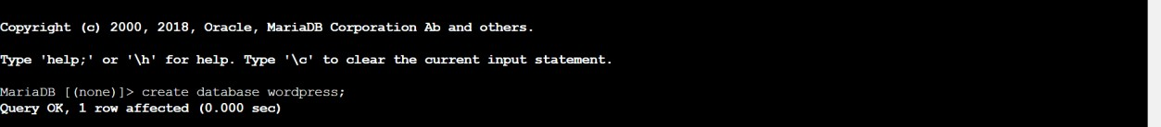

-for creating username and password: create user (username)@”%” identified by (password);

Error:syntax error

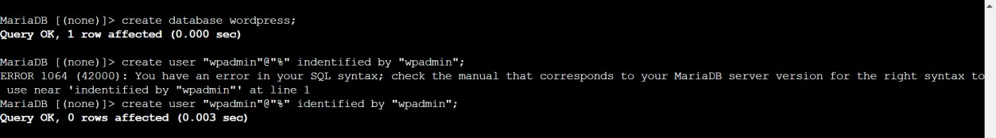

-to grant privileges: grant all privileges on (database name).* to (username)@”%”;

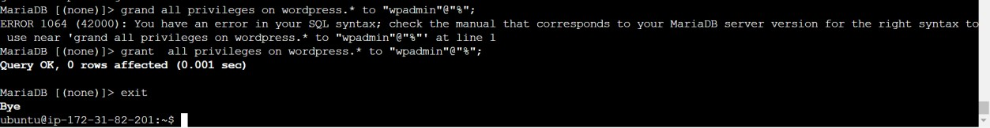

You are all set provide this information to your wordpress account Setup all this information to your wordpress account

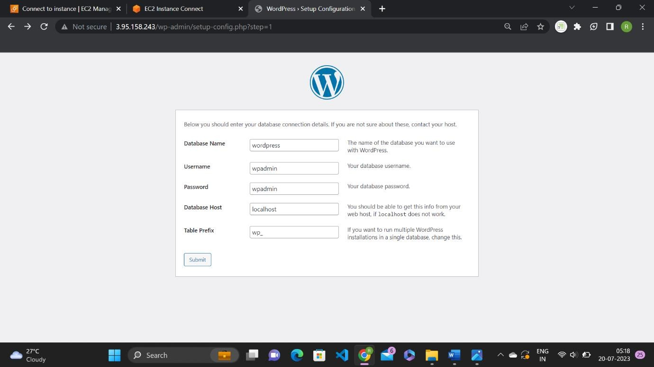

Click on submit

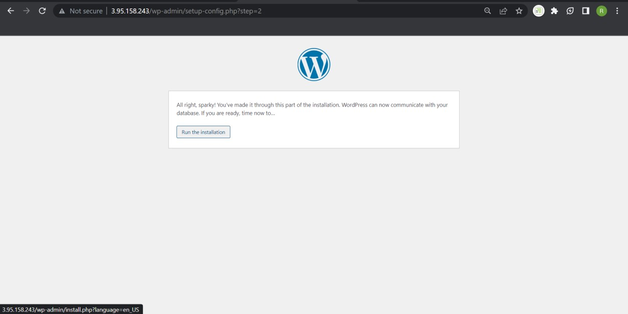

Click on run the installation

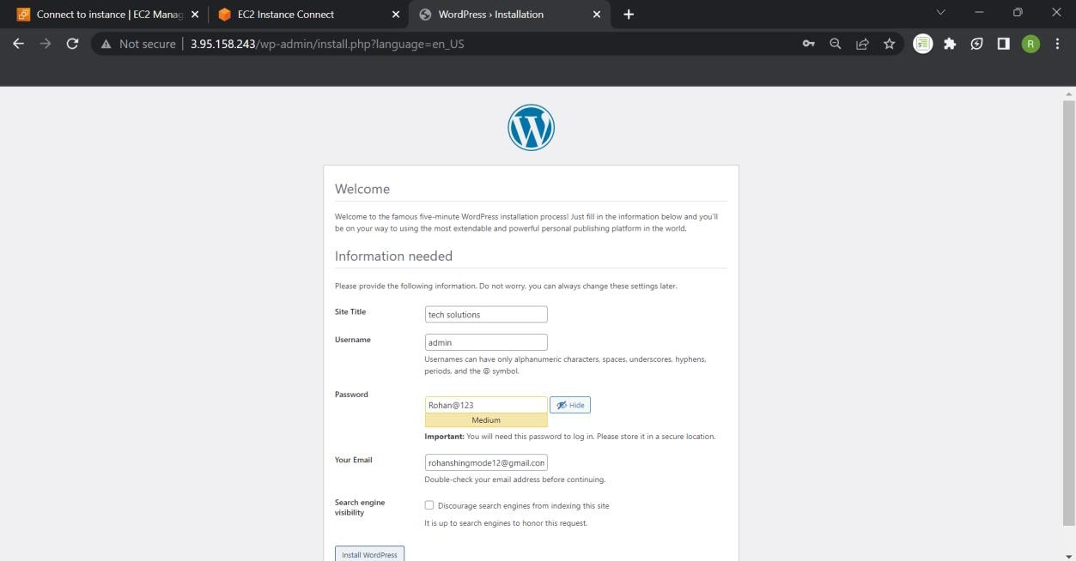

Type your username and click on install wordpress

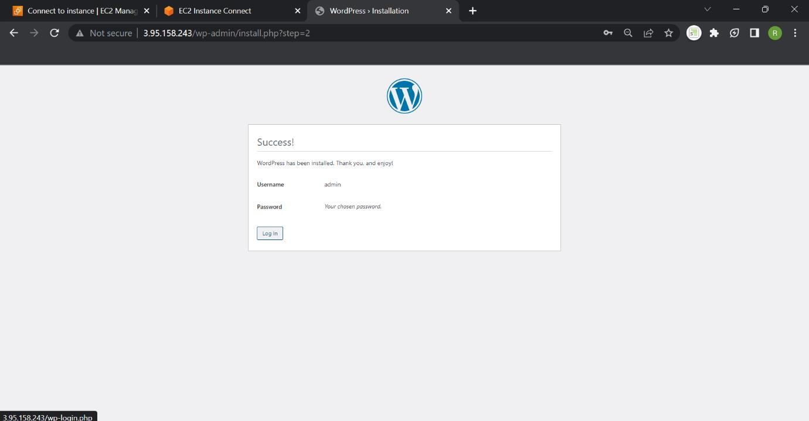

Click on login

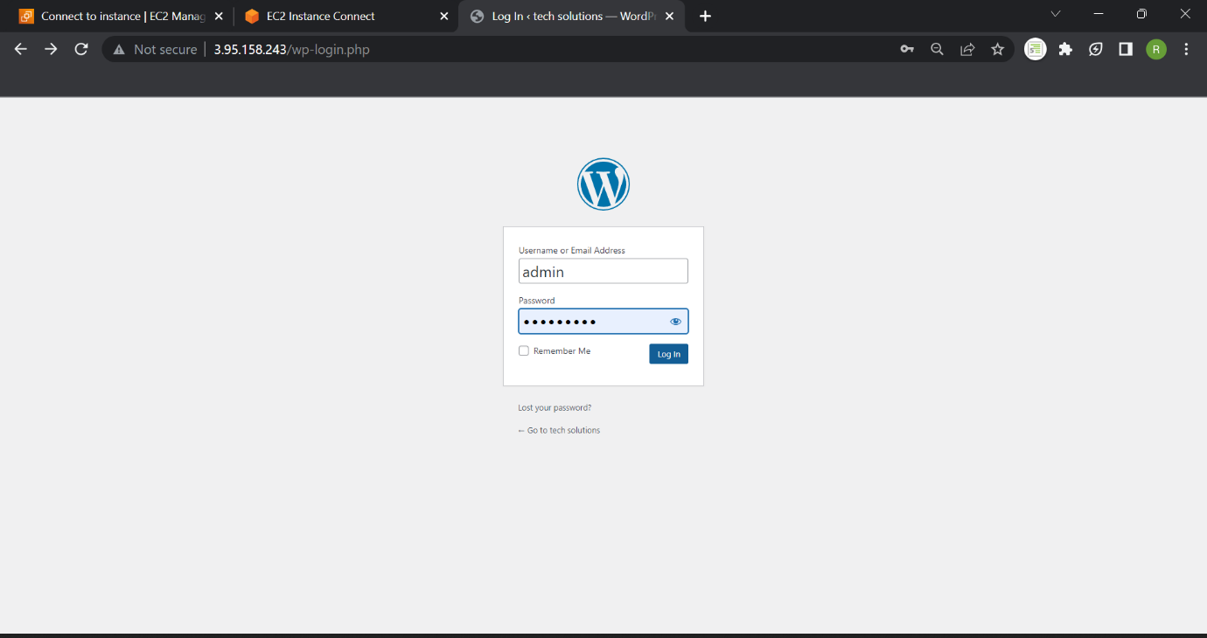

Click on login

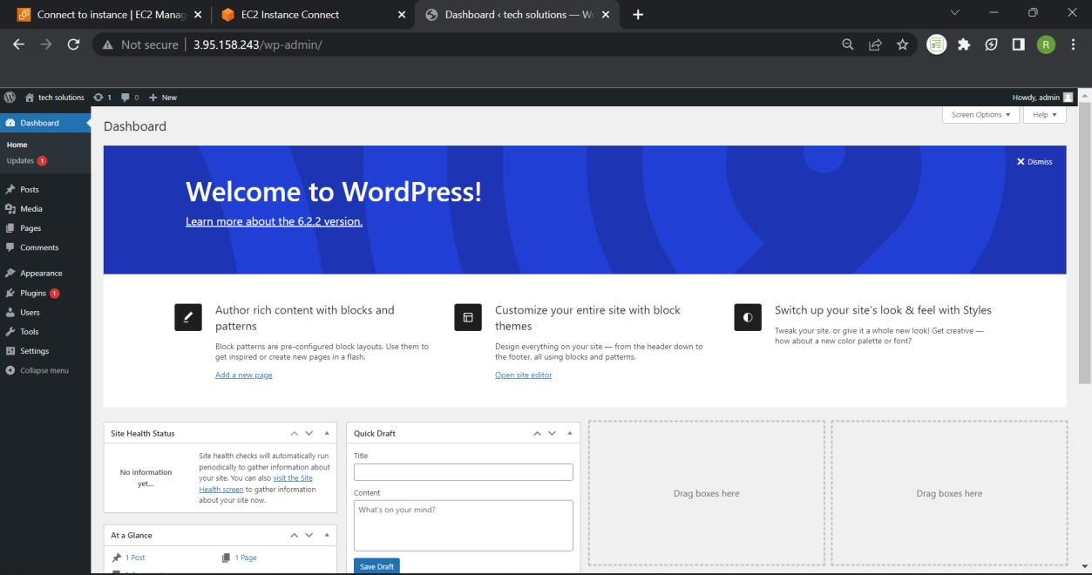

This is your dashboard

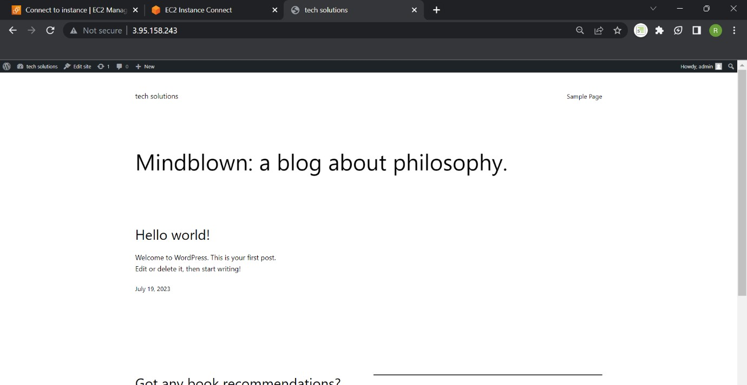

This your main website page.